|  |  |  |
| --- | --- | --- |
| **LAB 321Assignment** | **Type:** | **LongAssignment** |
| **Code:** | **J3.L.P0052** |
| **LOC:** | **600** |
| **Slot(s):** | **15** |

**Title:** Favorite Recipes

**Background**

A woman's blog, she writes about favorite recipes to share with everybody.

Sample site link: <http://us-123recipe.simplesite.com/422328403>

**Program Specifications**

Program a web site display all recipes. Each of recipes can be viewed detail. And, visitor can write comment.

**Features:**

This website contains following main functions

* Function 1: Display all recipesat home page – Screen code **S001**
  + Maximum of articles on home page is 9
  + Avatar of article is set general size
  + Each article be only display three information: avatar, title and abstract content
  + Use paging function at the bottom to view more articles
  + About the number of visitor, will be incremented when there is a new visitor
  + Display articles by some conditions : (1) total view  [***descending***](javascript:void(0))– (2) time upload newest
  + Click into avatar or title of article 🡪 display detail article (Screen code S003)
* Function 2: Visitor write free comment and display all comment of visitor – Screen code **S002**
* Display all comments by condition: time upload newest
* On comment page, only display maximum 10 comments.
* Use action scroll down to load more comment

Database description (recomment)

* Article
* Comment
* Num of Visitor

***Expectation of User interface:***

**S001**

➀ Menu home page. Action: Click 🡪 Open S001

➁ Menu comment of visitor. Action: Click 🡪 Open S002

➂ Articles list. Action: Click 🡪 Open S003

➃ Ads banner

➄ Total visitor

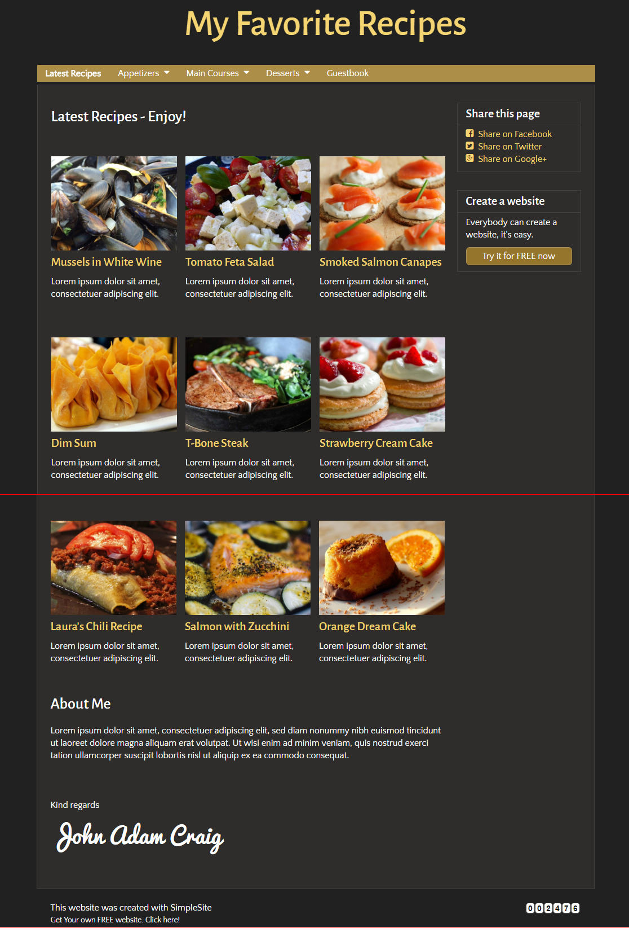

**S002**

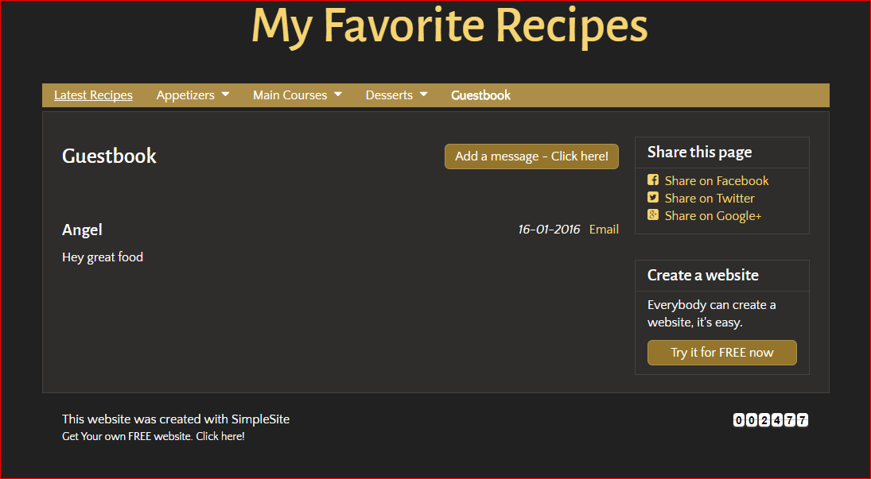

➀ Button add new comment of visitor. Action: Click 🡪 Load new form to fill comment (Screen code S004)

**S004**

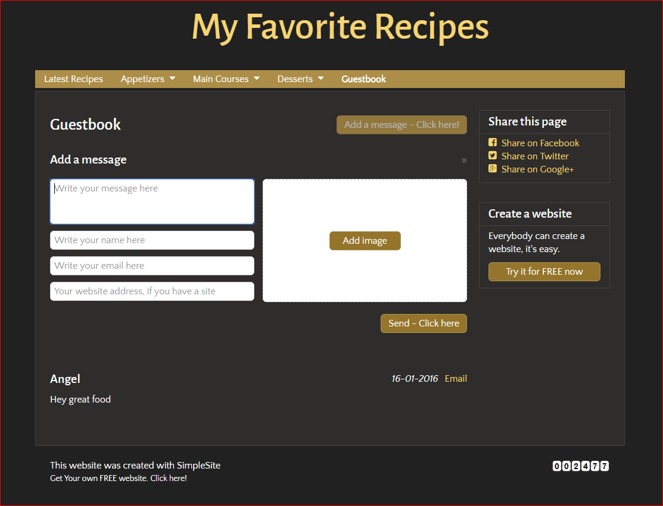

➀ Button Send comment. Action: Click send comment 🡪 Comment is added, back to screen S003 and load new comment.

**S003**

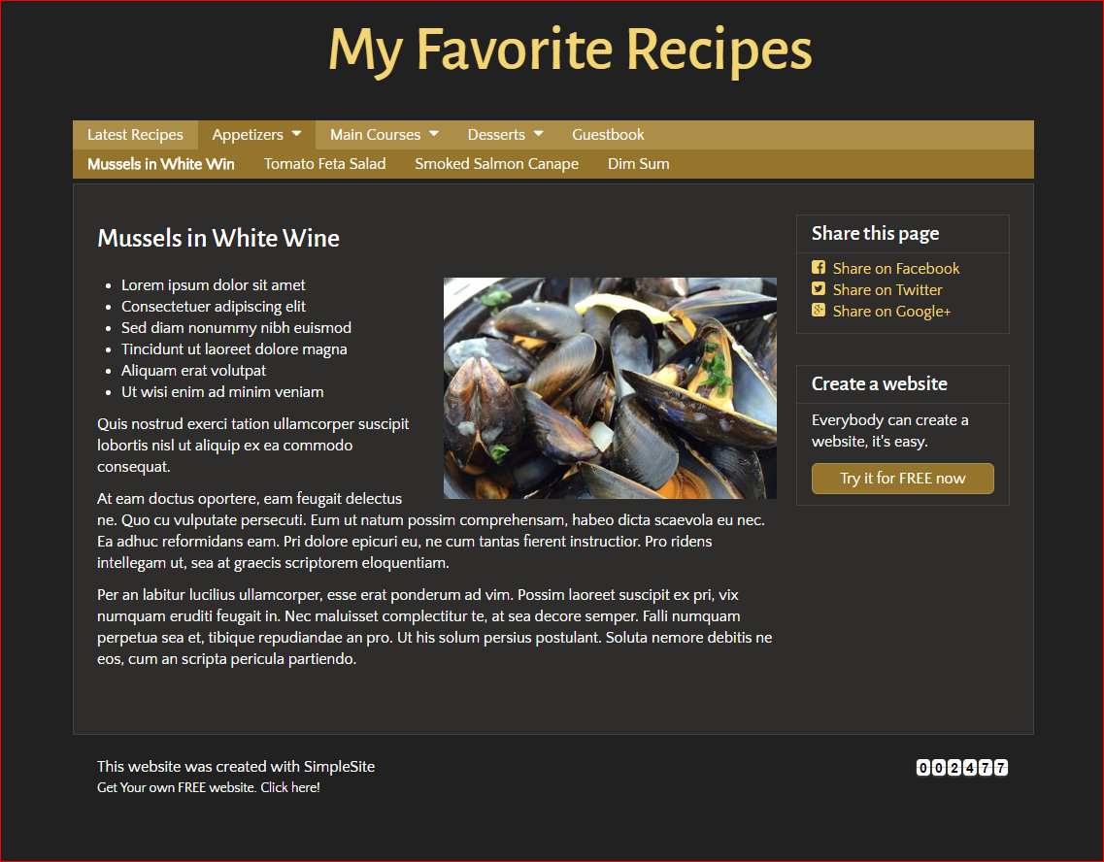

**Guidelines**

* Step 1 : Clarify requirement & scope with mentor
* Step 2 : Create prototype
* Step 3 : Design database , design class base on created prototype
* Step 4 : Code & Test